Kol Simcha Torah Gazette
For parshas noach 5786
Vol 10 Issue 5 (Whole #469) 3 Cheshvan 5786/ October 25, 2025
Printed L’illuy nishmas Nechama bas R’ Noach, a”h
For a free subscription, please forward your request to keren18@juno.com
Past emails can be found on the website ShabbosStories.com under Brooklyn Torah Gazette
Rav Avigdor Miller on
Enjoying Cold Weather

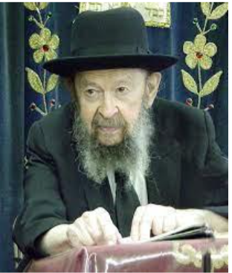

QUESTION: If a person likes very, very cold weather, let’s say zero degrees Farenheit, is he allowed to go outside and enjoy the weather and breathe in deeply to get the fresh air?
ANSWER: This question I don’t really understand, but I’ll try to answer it anyhow.
If a person enjoys cold weather, should he go out and breathe deeply and enjoy it?
It depends on his constitution. If he can take it, why not? No question, cold air is good clean air.
That’s one of the reasons for cold. Cold helps to purify the air. Cold inhibits certain organisms from growing. In the air, there’s dust; little dust particles are flying through the air all the time. And these little dust particles are airplanes on which microbes are sitting. No question about that. And so, the microbes are flying through the air all the time. But when it’s cold, they cannot increase or multiply and they’re limited in extent. Therefore, your body is able to combat the influence of a small amount of germs that are in the air.
And so, if you can breathe the fresh air of the cold weather, more strength to you.
If your constitution, however, is not able to take it, so look through the window and enjoy the cold air through the window pane.



Why do I say that? Because cold weather is good for the earth. So you’ll enjoy it from inside because the cold is causing the earth to stop producing. It’s only during the wintertime that the earth regains all of the materials that it lost in the summertime. And those materials are now in the earth and they’re decomposing—the snow and the rain help the process of the breakdown; all the compost, the leaves, everything else, is breaking down and it’s being now amalgamated again with the soil. The soil becomes rich again and next spring it’ll come out again.
So therefore, the cold is beneficial for the soil. So, you want to enjoy the cold that way, behind your window? Also good!

Reprinted from a recent email of Torah Avigdor based on a lecture delivered on. January 1990).

Preparing for the Seventh Millennium and the
Days of Moshiach
From the Teachings of the Lubavitcher Rebbe
Rabbi Menachem Mendel Schneerson, Zt”l
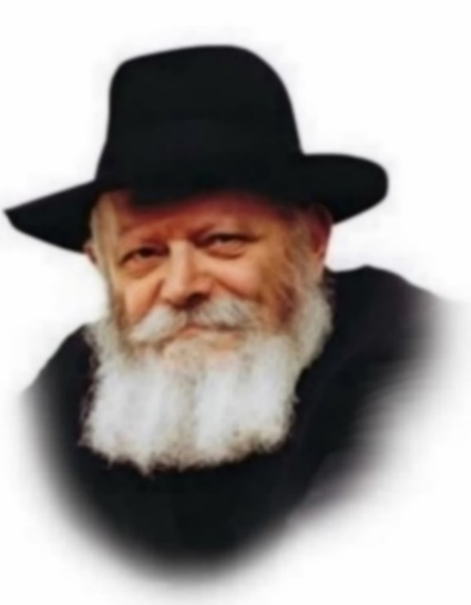
In this week's Torah portion, Noach, we read, "In the six hundredth year of Noah's life... all the fountains of the great deep were split and the windows of Heaven were opened." The Zohar, the basic book of Jewish mysticism, explains that this verse refers to the beginning of the sixth century of the sixth millennium of Creation (the year 5500, 263 years ago). At that time, the Divine fountains of knowledge would open up, both in the celestial spheres and in the physical realm, and the world would thus be prepared to enter the seventh millennium, the Messianic Age.
The Zohar describes the two types of knowledge that would be revealed during this time frame. The first is the opening of the "gates of knowledge above," referring to Torah and G-dly wisdom, and the second is the "fountains of wisdom below," referring to science and our understanding of the physical world.
Indeed, we find that the world began to undergo great changes in the 1700s, just as the Zohar prophesied. This was the time when Chasidic philosophy began to be revealed and scientific discoveries and developments began a frenetic pace that continues until today.
This period of revelation of knowledge, both G-dly and secular, came about as a preparation for the seventh millennium and the days of Moshiach. It is easy to understand how increased revelation of Torah serves as preparation, for the Messianic Era is a time when "knowledge of G-d will cover the earth like the water of the sea." But what has this to do with scientific advances and the Industrial Revolution?
A fundamental innovation of Moshiach will be that our perception of reality will change. Chasidic philosophy explains that after Moshiach reveals himself, "all flesh will see" - our physical flesh will be cognizant of the G-dliness that permeates and sustains the entire world.
Advances in scientific knowledge and understanding of the natural world are a preparation for this time. Medical, astronomic and nuclear discoveries have been revealed to man so that he can use this knowledge to serve G-d. As with everything else, we are given the free will with which to utilize these discoveries, as increased knowledge carries with it increased responsibility. When a Jew employs modern technology to serve G-d, perform mitzvot (commandments) and further goodness in the world, he is utilizing these revelations properly.
Our understanding of the dynamics of the physical world has increased so that we can elevate it more readily. Furthermore, the greater our understanding of science, the greater our understanding of the ultimate unity of G-d and Creation.
We see in the progress of history the positive development of knowledge and how it leads to an understanding of G-d. "Breakthroughs" in modern science continue to prove the unity of all creation and, ultimately of G-d.

Reprinted from the Parashat Noach 5763/2002 edition of L’Chaim, a publication of the Lubavitch Youth Organization. Adapted from the works of the Lubavitcher Rebbe.

Noach in a Nutshell

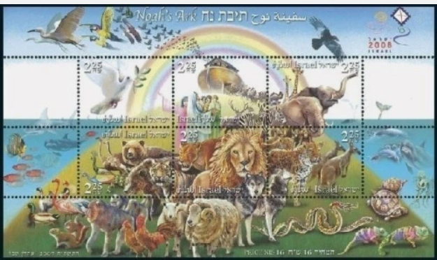
2007 Isreali postage stams (souvenir sheet – Scott Catalogue #1712a-f)

The Parshah (Genesis 6:9-11:32) is named "Noach" (Noah) after the protagonist of its major event: The Great Flood. It is found in Genesis 6:9.
G-d instructs Noah—the only righteous man in a world consumed by violence and corruption—to build a large wooden teivah (“ark”), coated within and without with pitch. A great deluge, says G-d, will wipe out all life from the face of the earth; but the ark will float upon the water, sheltering Noah and his family, and two members (male and female) of each animal species (and 7 of the "pure" species).
Rain falls for 40 days and nights, and the waters churn for 150 days more before calming and beginning to recede. The ark settles on Mount Ararat, and Noah dispatches a raven, and then a series of doves, “to see if the waters were abated from the face of the earth.” When the ground dries completely—exactly one solar year (365 days) after the onset of the Flood—G-d commands Noah to exit the teivah and repopulate the earth.
Noah builds an altar and offers sacrifices to G-d. G-d swears never again to destroy all of mankind because of their deeds, and sets the rainbow as a testimony of His new covenant with man. G-d also commands Noah regarding the sacredness of life: murder is deemed a capital offense, and while man is permitted to eat the meat of animals, he is forbidden to eat flesh or blood taken from a living animal.
Noah plants a vineyard and becomes drunk on its produce. Two of Noah’s sons, Shem and Japheth, are blessed for covering up their father’s nakedness, while his third son, Ham, is punished for taking advantage of his debasement.
The descendants of Noah remain a single people, with a single language and culture, for ten generations. Then they defy their Creator by building a great tower to symbolize their own invincibility; G-d confuses their language so that “one does not comprehend the tongue of the other,” causing them to abandon their project and disperse across the face of the earth, splitting into seventy nations.
The Parshah of Noach concludes with a chronology of the ten generations from Noah to Abram (later Abraham), and the latter’s journey from his birthplace of Ur Casdim to Charan, on the way to the land of Canaan.

Reprinted from the Chabad.Org website.

Insights into Parshat Noach
By Rabbi Berel Wein, zt”l

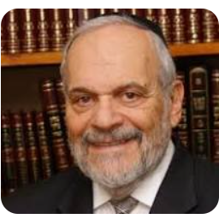

The opening sections of the Torah with which we are currently engaged in studying, deal with one of the central problems of human existence and that is the ability to cope with tragedy, disappointment and frustration. The adjustment of human beings to being driven out of the Garden of Eden is really the entire
story of human civilization and of its very bleak moments.
This week we read of the difficulty of Noach and his descendants to cope with the tragedy that they witnessed when the great flood destroyed the Mesopotamian human civilization.
There were different reactions to what they had witnessed and experienced. Noach himself forsook much of his spiritual greatness and accomplishment to
become a person of the earth, traumatized by the experiences of the past.
The English expression for this type of attitude is that one attempts to drown his sorrows away. As is recorded for us in this week’s Torah reading, this attitude and behavior leads to disaster and complete family dysfunction.
The opportunity for resilience, and family and national rebuilding is lost and squandered. There is a strong inclination within each of us to be overwhelmed by
challenging circumstances and tragedies. It is not easy to put one’s life back together after witnessing an event such as the great flood.
Yet, this is exactly what the rabbis pointed out to us as the major difference
between Noach and Abraham. Tested ten times, Abraham’s resilience never wanes, and he continues to look forward towards accomplishment.
This week’s Torah reading indicates another reaction to tragedy with rebellion and an abandonment of principles, beliefs and faith. The generations after the flood, in their anger and despondency over the punishment that Heaven meted out to human kind, rebelled against G-d and morality by building of the tower of Babel.
They knew of G-d and they knew of the flood, but they rebelled as a sign of their displeasure with what human kind suffered at the hands of Heaven. It is historically accurate to say that after great wars and tragedies, decades of decadence and immorality suffuse human society. It is this rebellion against what experience should have taught them that leads to further disaster. It is a different symptom of the same malady, the lack of societies and, as history has proven,
eventually leads to their demise and disappearance.
This description of human behavior as outlined above, is of enormous instruction to us in our time. We are still the generation reminiscent of the sword raised to destroy the Jewish people and endanger the existence of the Jewish
national state.
Only by our resilience and tenacity in following the lead of our father Abraham are we guaranteed to have overcome the challenges that face us.

Reprinted from the Parshat Noach 5786 email of R’ Yedidye Hirtenfeld’s whY I Matter parsha sheet for the Young Israel of Midwood (Brooklyn).

A Soviet-Born Mother’s Struggle to Raise Jewish Children in America
By Ph.D

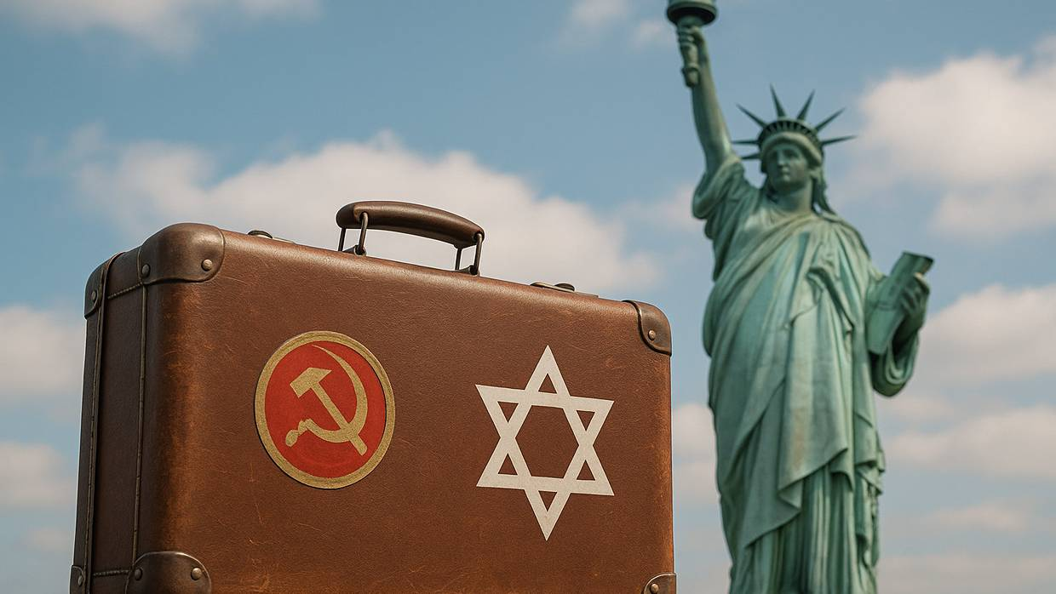

She escaped Soviet oppression, but now faces a new battle—keeping Judaism alive in her American-born children.
Back in Soviet Russia where I grew up, my grandma, who survived the Holocaust and lost her two precious little boys in the Minsk Ghetto, had to celebrate the Jewish holidays in secret. If the government discovered honey cake in the oven or gefilte fish in the fridge – attributes of her Jewish heritage – she would go to prison. And yet, she and my grandpa still set the table on Rosh Hashanah, gathered their family around it, and while dipping apples in honey, whispered prayers in Yiddish.
While getting ready for school the next morning, I was told not to tell anyone about our secret Jewish celebration. I would become a pariah, banned from the Young Communist Pioneer Club. Judaism was a dark, hidden secret, yet listed in my Soviet passport as a nationality. A daft paradox.
Then in 1991, after the fall of the Soviet Union, the antisemitic grasp on the regime loosened, and Jews were allowed to leave. My family, among millions of others, was able to escape to the safety of America, freefalling into the freedom of being ourselves – as Jews.
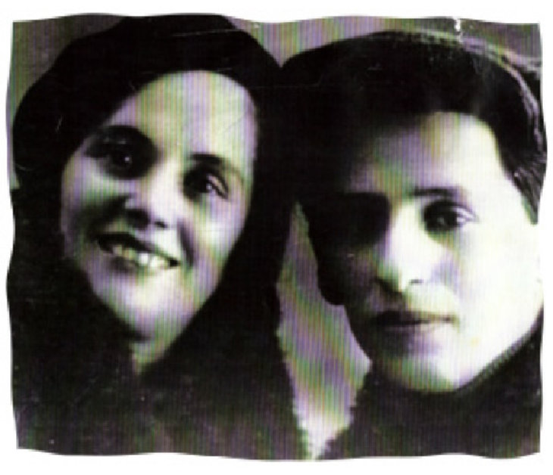My grandparents

We, especially those who came with young children, have been busy surviving, learning English, applying for jobs, establishing roots – becoming worthy citizens of our new world. And while doing so, many of us have neglected the Jewish aspect of ourselves, which apparently, as I discovered later, is a fundamental core within each of us. Yet, to so many, Judaism has become a distant echo of the past, an inconvenient non-priority.
Until...
For me, the turning point was when my grandmother passed away. One of my parents’ neighbors somehow knew that we were Jews and recommended a rabbi from a local temple to conduct a Jewish funeral.
Standing by my beloved grandma’s gaping grave, lost in grief and despair, I heard the rabbi singing prayers in a language I had never heard before: Hebrew. Suddenly, there was warmth in my chest followed by feelings of comfort and ease. This unexpected soothing – a glimpse of peace – was both welcoming and confusing at the same time. What was that about? According to the rabbi, that was my Jewish soul, neshamah, activated by his prayers, healing my broken heart.
I’ll take it.
Things changed after that and I became more Jewish. I sent my kids to Sunday Hebrew school, and then, years later, to a Jewish day school. My husband and I started attending classes at our local temple, learning about the spiritual aspect of our heritage, healing the ache of disconnection from our Jewish tribe imposed by the Soviet regime. And then, for our 25th wedding anniversary, surrounded by family and friends in front of our five children, we had the religious wedding ceremony under our very own chuppah.
So now, years later, many of us Jewish refugees who lost our parents or grandparents who had experienced the horrors of pogroms and the Holocaust, have felt the tremendous joy of picking up the pieces and celebrating our lives in our new post-war homelands: Israel and America.
Do we owe them continuing their legacy?
My grandma used to say that we avenge those who vanished at the hands of evil by thriving in our lives today, loudly and unapologetically. But can we truly be happy if our pursuit of happiness is only about prestigious college degrees and flashy cars? Those things are great, but life feels shallow and flimsy if we rely only on our material possessions for happiness. Judaism supplies this essence, a sense of belonging, a connection to something bigger, broader, wiser than us; a solid anchor in the turbulent sea of life.
So, as the years pass and we step into the role of matriarch or patriarch of our own families, the honor and responsibility fall on our shoulders to infuse our children with the light and love of Judaism – to gift them with its lasting essence. Especially in the post-October 7th world, when the world of every Jew was flipped upside down. We felt it, as if connected by some sacred web of ancestral DNA, making our hearts ache and our souls cry.
Today, kids proclaim: "It’s my life, and I get to do whatever I want." I could not agree more. But who are we, really, without our families, without our roots? Are we just drifters? It's our Jewish values and traditions that keep us grounded, connecting us to our tribe’s invisible network of safety. It’s our responsibility to show through small acts of Jewishness that we care.
So, I decide to take a stand on the eve of Rosh Hashanah, the Jewish New Year, when my kids tell me that they’re all too busy to get together to celebrate the Jewish holiday as a family. I hear a bunch of excuses – meetings, sports, tests – and I get mad and hurt.

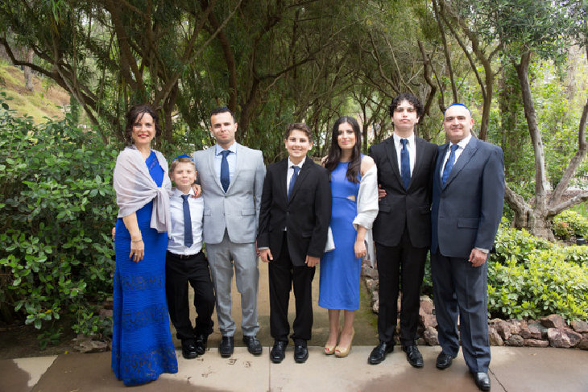

When something is important, we fight for it.
I swing the family room door open. Three heads are focused intently on a basketball game. “Excuse me, please,” I say, reaching for the remote control and pausing the TV. Three pairs of eyes are on me, displeased.
“If your great-grandma could celebrate religious holidays, risking her freedom and her life, why can’t you commit to treating your Jewish heritage as a priority for just a few times a year?" I begin my rampage. “And since when does freedom of choice evoke grunts of ignorance and ungratefulness? You are the kids of Jewish refugees and the descendants of Holocaust survivors. That should mean something to you.”
I look at my 23-year-old son, who is in the midst of signing an important real estate deal. “Your money comes from G-d, so it’s only appropriate to acknowledge Him during High Holidays,” I make my case.
Then, I turn to my 20-year-old, who has an important test on the night of Rosh Hashanah. “Reschedule the test.” I make it simple for him.
“When you have integrity within yourself and show respect for who you are and your values, others honor and respect you.”
Last is my 16-year-old, who tells me that his coach will hate him for missing his lacrosse practice and bar him from playing future games. “Tell your coach the truth,” I command, “that I am forcing you to stay home with your family and celebrate the Jewish new year. Text him now!”
With three heads nodding "okay," most likely to get rid of me and watch the game, I leave the room.
Minutes later my youngest rushes into my bedroom. “Mom!” he shows me his phone. “See what my coach wrote: "Shana Tova. Your mother is right. Enjoy time with your family.”
Every cell in my body applauds in celebration. I look straight at my son and say, “When you have integrity within yourself and show respect for who you are and your values, others honor and respect you.”
The next day, as my family gathers around the festive Rosh Hashanah table, dipping apples in honey for the sweet new year, I know they received a lesson that would make my grandparents proud.

Reprinted from the website of aish.com

Thoughts that Count
These are the generations of Noach: Noach was a just man in his generation (Gen. 6:9)
Rashi comments: This verse teaches us that the most important legacy of a righteous person is his good deeds. A righteous person is not defined by his lineage or by his noble ancestry, but by his own actions and behavior. (Divrei Yisrael)

A window shall you make for the ark (Gen. 6:16)
The Hebrew word for "ark" is "tayva," which also has the meaning of "word." A Jew's job is to make a "window," as it were, for the words he utters in prayer or in the study of Torah, and to let them illuminate, as the sun shines at midday. (Baal Shem Tov)

I will bring a flood of waters upon the earth, to destroy all flesh (6:17)
Why did G-d choose a flood with which to punish mankind? Could he not have chosen another method to destroy the wicked? The purpose of the flood, however, was to purify the world which had become unclean and defiled by its inhabitants. This is alluded to in the duration of the flood, forty days, and the requirement that a purifying mikva (ritualarium) contain at least forty sa'a (a specific measure) of water. (Rabbi Shneur Zalman)

And Noach went in, and his sons, and his wife, and his sons' wives into the ark (7:7)
A person should not content himself with his own entrance into the "ark"-the holy letters of prayer and of the Torah, but should always seek to bring others with him as well, not only members of his family but every fellow Jew. Just as G-d helped Noach by closing the door of the ark after all were safely inside, so, too, is every Jew assisted by G-d when he comes to the aid of his fellow man. (Lubavitcher Rebbe)

And only Noach was left (7:23)
Despite the fact that Noach was a righteous person, he was still required to tend to all the animals in the ark and take care of their needs. This was a physically demanding and sometimes dangerous job. Similarly, no matter how high a spiritual level one reaches, he is still obligated to take care of those around him who may need his guidance. (Likutei Sichot)

Reprinted from the Parashat Noach 5763/2002 edition of L’Chaim

